# **Design and Numerical Simulation of MEMS Microheater for Gas Sensing Application**

K.Karthikeyan1\*, P.Subash2, M.Sivaramakrishnan3, S.Vigneshwaran4 and S.Yasar5

1Centre of Excellence in PCB, Department of Electronics and Communication Engineering, M.Kumarasamy College of Engineering, Karur, Tamil Nadu, India 639113.

2Department of Electronics and Communication Engineering,

M.Kumarasamy College of Engineering, Karur, Tamil Nadu, India 639113.

Email ID: [karthimems@gmail.com](mailto:karthimems@gmail.com)

## **ABSTRACT**

Micro Electromechanical System (MEMS) technology has always been the most important part in the development of micro-heaters and thus, high-performance gas sensors. Micro-heaters have been widely used in gas sensors with high sensitivity. This paper provides the design and simulation of serpentine shape micro-heaters with interdigitated electrodes (IDE). We have studied different heater materials such as copper, nickel, silver, gold and platinum over the polycrystalline substrate for achieving low power consumption, uniform temperature distribution and long-term stability high mechanical strength.

**Keywords** **used****:** MEMS, Microheater, Temperature distribution, Electric potential, stress.

**1.Introduction**

*Micro Electromechanical System which is usually* *called MEMS****.*** *MEMS**based gas sensors being miniaturized have various advantages such as low power consumption, robust and stable electric properties. These gas sensors have three main components interdigitated electrode and sensing* *film. Within the traditional MHP gas sensor, the heating electrodes and the test electrodes are not on the same plane. With such traditional design, the manufacturing process is complex, and the heat transfer is not very good, and a parasitic electric field is likely to take form among the heating layer,* *insulating layer and testing layer, exerting certain influences on the signal to be tested. In this new design, the heating electrode and the testing electrode are placed on the same plane.*

*In this paper the design and simulation of serpentine shape micro heaters were used for the analysis of uniform temperature distribution, power consumption* *because of its* *higher efficiency and higher operating* *temperature. Interdigitated electrodes are used because the reduced distance between the electrodes enable quicker ion diffusion leads to higher power density and* *performance. Micro heaters play a key role in controlling temperatures in lab-on-chip devices due to* *their ability to affect the temperature locally. Micro* *heaters based on* *Gold have excellent physical properties like gold can be able to reflect the heat rather than other* *materials. Gold can efficiently transfer heat and* *electricity. By* *analyzing the various properties like low power* *consumption, least volume change* *during* *heating, better temperature uniformity of different micro heater materials such as* *copper, silver, nickel,* *platinum. Gold* *gives better results when compared to others.* *Geometry,* *temperature and electric field norms* *are attached below.*

***2.Geometry***

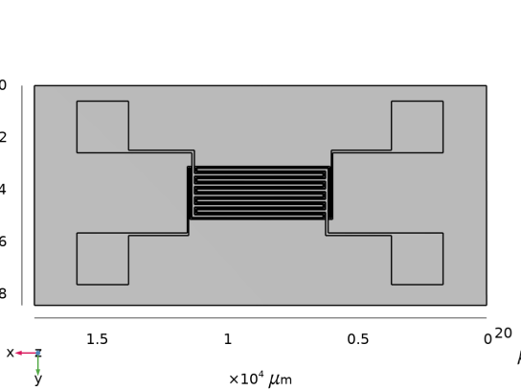

***Figure 1. Geometrical design of*** ***Microheater. Unit*** ***(µm)***

|  |  |
| --- | --- |
| ***DESCRIPTION*** | ***VALUE*** |
| *Space dimensions* | *3* |
| *Number of boundaries* | *4* |
| *Number of Domains* | *164* |
| *Number of edges* | *468* |
| *Number of Vertices* | *312* |

*Here the gap between the Two electrode is 50µm and the* *width of the electrode laid on up is 100µm and* *electrode laid* *downside is 50µm width.*

***Table*** ***1: Geometry statistics***

**3.****Gold (Au)**

|  |  |  |
| --- | --- | --- |
| **Name** | **Value** | **Unit** |
| Electrical conductivity | 45.6e6[S/m] | S/m |
| Coefficient of thermal expansion | 14.2e-6[1/K] | 1/K |
| Heat capacity at constant pressure | 129[J/(kg\*K)] | J/(kg·K) |
| Density | 19300[kg/m^3] | kg/m³ |
| Thermal conductivity | 317[W/(m\*K)] | W/(m·K) |
| Relative permittivity | 1 | 1 |
| Relative permittivity | 70e9[Pa] | pa |
| Poisson's ratio | 0.44 | 1 |

**Table 2: Material parameters for gold**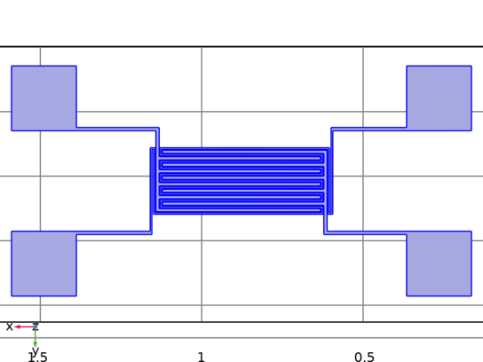

**Figure 2. Design of Gold based Microheater.**

**4.Temperature Distribution in** **Gold**

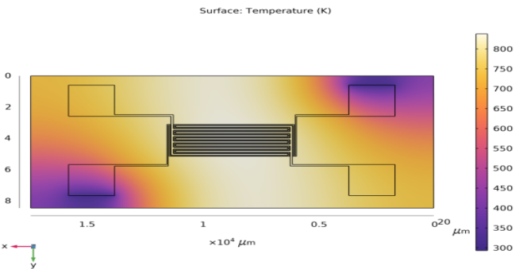

**Figure 3. Temperature distribution in Gold Microheater.**

From this figure 3. We can find that heat at the Centre of the material is very high. Heat is uniformly spread all over the material by which the size of the material plays a vital role in temperature distribution and low power consumption.

**ρ = RA/l**. (1)

ρ - Resistivity

R-Resistance of the specimen

A-area of cross section

L-length of the conductor

Where the resistivity of a material Is dependent on the length of the conductor.

**The highest temperature** **attained by the gold is 829****K at 1 volt of input supply.**

**5.Electric potential**

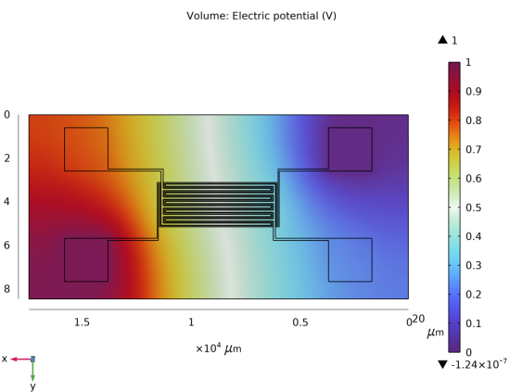

**Figure** **4**. **Electric potential distribution in Microheater**

From figure 4. field strength at the one corner is greatest and field strength

Another corner is weakest which is grounded and field strength at the middle is 0.5V.

**6.STRESS ANALYSIS**

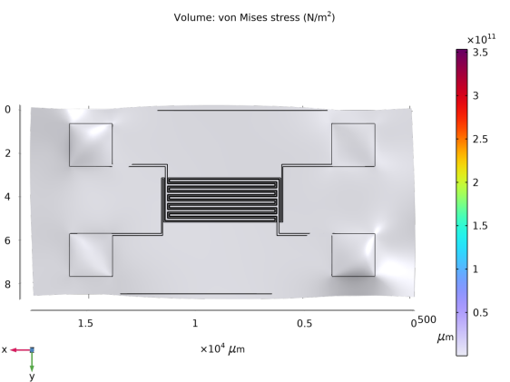

**Figure 5. Stress** **in the Microheater.**

From figure 5. stress all over the substrate is very low but stress at the electrode is very high which means the electrode can withstand a huge external force.

**7.Conclusion**

Test and Simulation were done for the Parallel plate Microheater, and various temperature obtained for applying five different voltages to different heating elements like platinum, copper,nickel,silver. And the suitable heating element(gold) was selected as the best among the other.in future after the fabrication of this micro heater it can be subjected to the extensive applications like gas sensors, humidity sensors, and others. And by analyzing the micro heater design using MEMS based COMSOL software we have found that gold has low thermal mass and better temperature uniformity.

**8.Acknowledgement**

This research was supported by the Centre of Excellence in PCB, Department of Electronics and Communication Engineering M Kumarasamy college of Engineering karur.

**9.References**

# [1] [Z. E. Jeroish](https://link.springer.com/article/10.1007/s10544-021-00595-8" \l "auth-Z__E_-Jeroish), [K. S. Bhuvaneshwari](https://link.springer.com/article/10.1007/s10544-021-00595-8" \l "auth-K__S_-Bhuvaneshwari),[Fahmi Samsuri](https://link.springer.com/article/10.1007/s10544-021-00595-8" \l "auth-Fahmi-Samsuri) & [Vigneswaran Narayanamurthy](https://link.springer.com/article/10.1007/s10544-021-00595-8" \l "auth-Vigneswaran-Narayanamurthy) *[Biomedical Microdevices](https://link.springer.com/journal/10544)* Microheater: material, design, fabrication, temperature control, and applications—a role in COVID-19

[2]  *L X He, F Wang, G Q Niu, H M Gong, Z T Yang, W He and J M Cao Design of Mems-based Gas Sensor Micro Heat Plate.*

*[3] Micro* *Heaters <https://www.ist-ag.com/en/micro-heaters>*